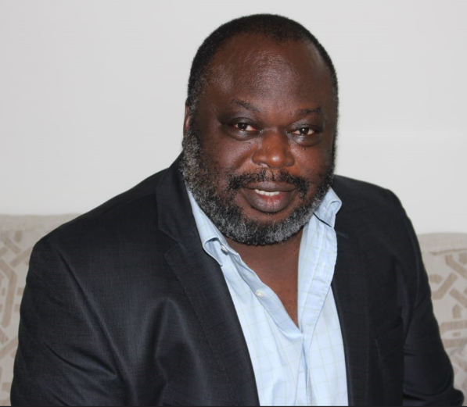

**Prof. James O. B. Rotimi**

*Professor of Construction Economics and Management*

*PhD, MSc, BSc, PGCert, HND, GradDipHE, FCIOB, MRICS, MNZIOB, MNIOB, MIMC*

*Chartered Construction Manager, Building Professional & Quantity Surveyor*



Name:- Agboola Shamsudeen Abdulazeez

Contact info:- House No.30B Agwan Dutse Bauchi Ring Road Jos, Plateau State

List of Publication:- https://www.researchgate.net/profile/Shamsudeen-Abdulazeez-2

Qualification:- BTech; MTech. MNIOB

Rank:- Lecturer II



Name:- Aminu Wali Bashir

Contact info:- B10, FRCN Senior Staff Quarters, Malali. Kaduna State

List of Publications: -

* Aminu Wali Bashir, Brenda Chaves Coelho Leite ‘Performance of aerogel as a thermal insulation material towards a sustainable design of residential buildings for tropical climates in Nigeria’ Journal of Energy and Built Environment. https://doi.org/10.1016/j.enbenv.2021.02.003
* Aminu Wali Bashir, Eliane Hayashi Suzuki, Joao Roberto Diego Petreche, Brenda Chaves Coelho Leite ‘Performance of aerogels as a thermal insulation materials for buildings in tropical climates’ (Article accepted for publication) Building Simulation Conference; BS 2021. https://doi.org/10.26868/25222708.2021.30800
* Ahmad Abubakar, Aminu Wali Bashir, Carlos F. M. Almeida, Brenda Chaves Coelho Leite ‘Designing energy-efficient residential buildings for Nigeria and sub-Saharan Africa considering aerogel thermal insulation material and photovoltaic power generation’ The 26th International Conference & Exhibition on Electricity Distribution; CIRED 2021. https://doi.org/10.1049/icp.2021.2094

Qualification: - B.Sc., M.Sc.

Rank:- Assistant Lecturer



Name:- Aliyyu Abiola Abdulraheem

Contact info:- NO 30,Ifesowapo Agbojulogun CDA Zone “A” Ogidi Oloje Ilorin,Kwara State.

List of Publication:- Nill

Qualification:- B.Tech

Rank:- Graduate Assistant



Name:- Abbas Khadija Ibrahim

Contact info:- House no: 82 University staff Quarters Giri, Gwagwalada, Abuja.

List of Publication:-

Qualification:- B.Sc., PGD,M.sc

Rank:- Technologist I



Name:-

Contact info:- Halimat Ajoke House, Sheikh Adam Abdullahi Street, Ita-nma, Ilorin, Kwara State.

List of publications: - Nill

Qualification: - BEng.,GMNSE, R.Engr (COREN) Aff. ASCE

Rank: - Technologist II